Tower Defence Games

**Overview:**

* At the core, tower defence games are about the player stopping enemies from reaching the end of a track
* This is done by placing different forms of “towers” (subject to change based on theme) along the outside of the track
* “Towers” automatically destroy enemies but the time to destroy enemies varies (for added difficulty)
* “Towers” can be upgraded although when upgrades are applied varies between after a wave of enemies or as the enemies are appearing

**Core Loop:**

**Smart Depth:**

* The depth from tower defence games mainly comes from the ability to upgrade the towers. This allows a player to form strategies based on the best time to upgrade versus which upgrade to get based on cost, need or want.
* Secondary depth source comes from where to place the towers, again allowing players to form strategies. Players ask themselves questions like, “Where should I place towers at the start?”, “Should I group them together or spread them out?”, etc.
* Lastly, the added depth can also come from decisions whether to upgrade towers or buy new towers, again allowing the players to form strategies.

**Demographics:**

This is mainly determined by the theme, for example:

* A war theme will appeal mainly to males aged 16-24
* Whereas a game themed similarly to Plants vs Zombies appeals mainly to 13 – 19 year olds

**Art Styles:**

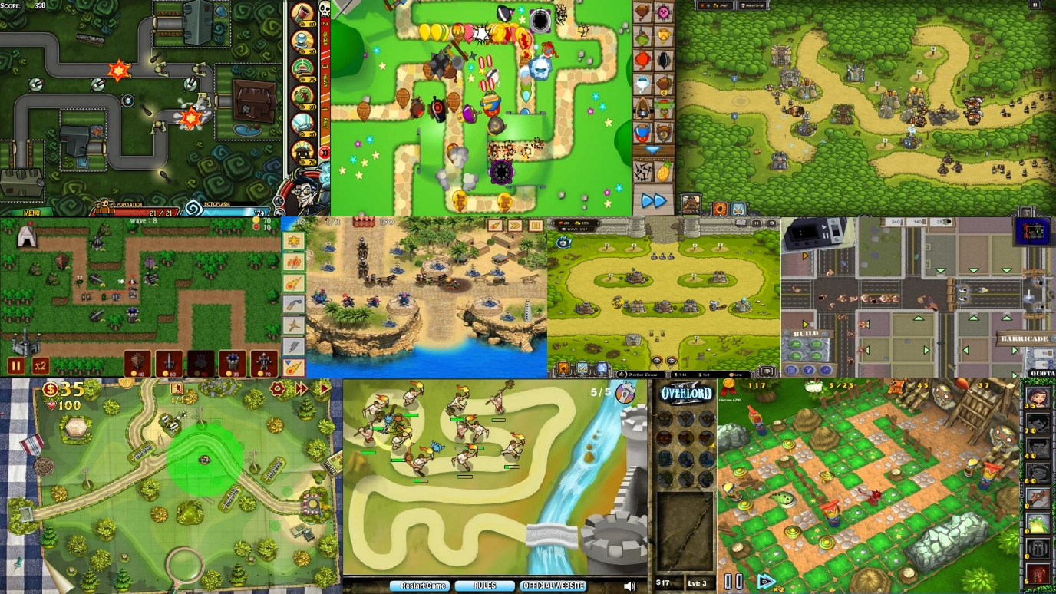

As shown above, the following items are consistent across the art styles:

* 2D
* Forest/grass theme with a worn-down path
* Basic, cartoon-like art style with little variation
* UI follows similar placements throughout; e.g. tower menu on the right-hand side of the screen, points/currency starts in the top left corner
* Clear definition between path and background

**Potential Challenges:**

* The demand for tower defence games has decreased significantly since the first tower defence games appeared. While this can be for a variety of reasons, the most commonly accepted reason, is that players don’t want to sit and watch a level complete itself, after they have placed their towers. (Rigney, 2013).
* A huge number of different themes have been used in tower defence games, from monkeys and balloons to ships in space, therefore, it would be a difficult challenge to make a tower defence game stand out.
* Due to free game websites, there is a large amount of tower defence games available for a player to look at, without having to pay for them. This would hinder any potential for monetising a tower defence game as players will feel like they have plenty of free options instead of a paid option.

**Unique Elements:**

* 3D rather than 2D
* Combination with other genres, or using elements from other genres; e.g. RPG-like stats for towers that can be upgraded, or a rhythm based firing system for the towers.
* Use of underused themes, like a tower defence game based around a PC theme; e.g. the player must stop viruses from entering the PC, thus acting as the firewall/anti-virus.